

STUDENTAL PLATFORM,

THE WEBSITE OF OPPORTUNITIES

GRADUATION PROJECT

AMANDA PEZA

EPOKA UNIVERSITY

FACULTY OF ECONOMICS AND ADMINISTRATIVE SCIENCES

DEPARTMENT OF BUSINESS ADMINISTRATION

BUSINESS INFORMATICS

TIRANA, ALBANIA

May 2024

STUDENTAL PLATFORM,

THE WEBSITE OF OPPORTUNITIES

AMANDA PEZA

Thesis Submitted in Fulfillment of Requirement for the Degree of

 Bachelor in Business Informatics.

EPOKA UNIVERSITY

May 2024

**APPROVAL PAGE**

**Student Name & Surname:** Amanda Peza

**Faculty:** Faculty of Economics and Administrative Sciences

**Department:** Business Administration

**Thesis Title:**  Studental Platform, the website of opportunities

**Date of Defense:** 21 May 2024

I certify that this final work satisfies all the requirements as a Graduation Project in Business Informatics.

Dr. Esmir Demaj

**Head of Department**

This is to certify that I have read this final work and that in my opinion it is fully adequate, in scope and quality, as a Graduation Porject in Business Informatics.

M.Sc Enesh Orazova

**Supervisor** 

**Examination Committee Members**

      Title / Name & Surname                 Affiliation   Signature

1-

2-

3-

i

**STUDENTAL PLATFORM,**

**THE WEBSITE OF OPPORTUNITIES**

**ABSTRACT**

The diploma thesis titled "Studental: A Centralized Platform for Student Opportunities in Albania" addresses the challenges faced by students in accessing relevant internship, scholarship, employment, and training opportunities in Albania. The project aims to streamline the process of opportunity discovery, enhance career exploration, and bridge the gap between theoretical knowledge and practical experience for students.

The solution proposed is the development of the Studental platform, leveraging WordPress for web development, to connect students with diverse opportunities both within Albania and internationally. Key features include user registration and profiles, opportunity listings with search functionality, a user-friendly dashboard, accessibility features and mobile responsiveness.

The project scope encompasses the development, implementation, and maintenance of the Studental platform. The thesis objectives include facilitating access to opportunities, bridging the knowledge gap, empowering decision-making, streamlining the process, fostering

ii

community engagement, expanding global reach, and promoting career development. The project aims to create a valuable resource for students, ultimately contributing to their success in transitioning from university to the real work environment.

The methods used in developing the platform involve iterative design and development processes, user feedback incorporation, and continuous. Results are expected to show improved access to opportunities, enhanced user experience, increased user engagement, and

positive impacts on students' career paths. Overall, the Studental platform serves as a comprehensive solution to address the challenges faced by students in Albania, providing a centralized hub for opportunity exploration, career development, and community networking.

iii

**ACKNOWLEDGEMENTS**

I am deeply grateful for the invaluable support and guidance I received during my graduate studies, without which this thesis would not have been possible. I extend my sincere thanks to M.Sc. Enesh Orazova, my mentor and dissertation supervisor, whose expertise and guidance have been instrumental throughout my academic journey. Working under her supervision has been an enriching and fulfilling experience.

I am also indebted to Giljana Limani and Rudi Guri for their significant contributions to the early stages of this project. They played a crucial role in shaping the development of this thesis, and I am thankful for their valuable insights and input.

My appreciation also goes to my fellow graduate student colleagues, whose camaraderie and support have been invaluable throughout the challenging coursework and exams.

I would like to express my deepest appreciation to my family for their unwavering support. I thank my parents for their love, patience, encouragement and understanding during this academic endeavor.

iv

**DECLARATION**

I hereby declare that this Bachelor Thesis named “Studental Platform, the website of opportunities” is based on my original work except quotations and citations which have been duly acknowledged.  I also declare that this thesis has not been previously or concurrently submitted for the award of any degree, at EPOKA University, any other university or institution.

Amanda Peza

Date:

v

**TABLE OF CONTENTS**

**APPROVAL**  i

**ABSTRACT**  ii

**ACKNOWLEDGEMENTS**  iv

**DECLARATION**  v

**TABLE OF CONTENTS**  vi

**LIST OF FIGURES**  ix

**LIST OF DIAGRAMS**  x

**CHAPTER I**

**1 INTRODUCTION**........................................................................................................1

1.1 Problem identified...................................................................................................1

1.2 Proposed Solution...................................................................................................2

1.3 Project Scope..........................................................................................................2

1.4 Objectives...............................................................................................................3

**CHAPTER II**

**2 LITERATURE REVIEW**............................................................................................5

**CHAPTER III**

**3 SOFTWARE DESIGN AND ANALYSIS** ..................................................................7

3.1 Product description....................................................................................................7

3.1.2 Key features and functionalities......................................................................7

vi

3.1.3 Intended users.....................................................................................................8

3.1.4 Addressing user needs........................................................................................8

3.2 Product Prespective...................................................................................................9

3.3 Product Function........................................................................................................9

3.4 Software Requirements..............................................................................................10

3.4.1 Software Process Model..................................................................................10

3.4.2 User Requirements..........................................................................................10

3.4.3 Functional Requirements................................................................................. 11

3.4.4 Non-Functional Requirements.....................................................................…12

3.4.5 Safety Requirements ....................................................................................... 13

3.4.6 Security Requirements..................................................................................... 14

3.5 Diagrams……............................................................................................................ 16

3.5.1 Component Diagram........................................................................................16

3.5.1 Class Diagram................................................................................................. 18

3.5.2 Database Diagram............................................................................................20

3.5.4 Sequence Diagram...........................................................................................22

**CHAPTER IV**….................................................................................................................... 23

**4 TOOL AND ENVIROMENT**..........................................................................................23

4.1 Hardware Interface.....................................................................................................23

4.2 Software Interface .....................................................................................................24

**CHAPTER V**....................................................................................................................... 25

**5 TESTING**........................................................................................................................ 25

6.1 Test Case................................................................................................................... 25

vii

**CHAPTER 7**…..........................................................................................................................30

**7 CONCLUSION AND FUTURE WORK**.....................................................................30

**REFERENCES**.......................................................................................................................32

**APPENDICES** ........................................................................................................................33

Appendix A Website Screenshots .........................................................................................33

viii

**LIST OF FIGURES**

Figure 1.1 Website Homepage, first part 34

Figure 1.2 Website Homepage, second part 34

Figure 1.3 Website Homepage, third part 35

Figure 1.4 Website Homepage, fourth part 35

Figure 2.1 All Opportunities Page, after clicking ‘Explore Opportunities’ button 36

Figure 3.1 One opportunity opened after clicking ‘Read more’ button first part 36

Figure 3.2 One opportunity opened after clicking ‘Read more’ button second part 37

Figure 4.1 Login example 37

Figure 5.1 User Dashboard 38

Figure 5.2 User Profile Settings 38

Figure 5.3 User Wishlist 39

Figure 6.1 ‘About Us’ page, first part 39

Figure 6.2 ‘About Us’ age, second part 40

Figure 7.1 ‘Contact Us’ age, first part 40

Figure 7.2 ‘Contact Us’ age, second part 41

ix

**LIST OF DIAGRAMS**

Diagram 3.2.2 Component Diagram 16

Diagram 3.2.3 Class Diagram 18

Diagram 3.2.4 Database Diagram 20

Diagram 3.2.5 Sequence Diagram 22

x

**CHAPTER 1**

**INTRODUCTION**

* 1. **Problem identified**

Students face challenges regarding their interests/career decisions, this includes the difficulties of accessing relevant opportunities to ease the transition from university to the real work environment, the need to bridge the gap between their theoretical background and practical skills, as well as to gain experience to prepare for their dream job or reach a certain level.

● Diverse Opportunities: There are various opportunities available to students, including internships, training, employment opportunities, competitions, summer schools, conferences, and workshops. This shows the breadth of options students have but also the potential complexity in finding the right fit.

● Fragmented Information: These opportunities are scattered across numerous websites and social media platforms, making it difficult for students to track them down. This fragmentation adds an extra layer of difficulty in accessing relevant information.

● Time and Effort: Searching through hundreds of websites, verifying the accuracy and validity of information, and navigating through different formats and sources can be time-consuming and tedious for students. This can lead to demotivation and frustration.

● Relevance: Many opportunities may not be relevant to Albanian students due to specific requirements or restrictions, such as those designed for EU or international students. This further complicates the search process and adds to the time wasted.

1

● Importance of Opportunities: The significance of these opportunities in helping students is important in exploring their career paths, passions, and interests. This emphasizes the importance of streamlining the process for students to access relevant opportunities efficiently.

* 1. **Proposed Solution**

The solution proposed to address the identified problem is a platform designed to connect students with internship, scholarship, employment, training opportunities, and more in Albania. This platform aims to help students explore their passions and interests, facilitating their success in their careers. Users will have the chance to discover opportunities not only within the borders of Albania but also wherever Albania is eligible to participate globally. The website aims to streamline the search process by consolidating all available opportunities in one user-friendly interface, while continuously gathering feedback from users and stakeholders to improve and enhance the platform’s functionality, usability, and relevance to students’ needs.

* 1. **Project Scope**

The scope of this project encompasses the development of a platform aimed at connecting students in Albania with internship, scholarship, employment, training opportunities, and more. The platform will serve as a centralized hub for students to explore various opportunities related to their career interests and academic pursuits.

2

*Boundaries and Limitations:*

● Geographical Limitation: The platform will focus primarily on opportunities available within Albania, with the inclusion of international opportunities accessible to Albanian students.

● Technology Limitation: The platform will be developed either as a website using WordPress.

● Accessibility: While the platform aims to be accessible to all students, including those with disabilities, the scope will prioritize adherence to accessibility standards and guidelines within the chosen development framework.

* 1. **Objectives**
* Facilitate Access: Provide students with easy access to a diverse range of opportunities related to their academic and career interests, reducing the time and effort required to search for relevant options across multiple sources.
* Bridge Knowledge Gap: Bridge the gap between theoretical knowledge gained in university and practical experience needed in the real work environment by offering opportunities that allow students to apply and enhance their skills in real-world settings.
* Empower Decision-Making: Empower students to make informed decisions about their career paths by offering a comprehensive platform where they can explore various opportunities and assess their compatibility with their interests, qualifications, and aspirations.

3

* Streamline Process: Streamline the process of searching for and applying to opportunities by offering robust search and filtering functionalities, user profiles, and a user-friendly interface that enhances usability and efficiency.
* Foster Community Engagement: Foster a community-driven platform where students can share their experiences, insights, and tips related to various opportunities, creating a supportive environment for career development and networking.
* Expand Global Reach: Include opportunities not only within Albania but also internationally, wherever Albanian students are eligible to participate, expanding their horizons and global networking opportunities.
* Promote Career Development: Support students in their career development journey by offering resources, guidance, and opportunities for professional growth and advancement, ultimately contributing to their success in the transition from university to the real work environment. By achieving these objectives, the project aims to create a valuable resource for students in Albania, empowering them to explore, pursue, and succeed in their chosen career paths.

4

**CHAPTER 2**

**LITERATURE REVIEW**

The "Website Studental" project aims to address the challenges faced by students in Albania regarding accessing and navigating various opportunities related to internships, scholarships, employment, and training. This literature review will delve into existing research and initiatives that align with the goals and objectives of the project.

**Student Career Development and Support:** Numerous studies emphasize the importance of career development support for students. Research by Savickas (2011) highlights the role of career interventions in assisting students in making informed career decisions and navigating their career paths effectively.

**Centralized Platforms for Opportunity Access:** The concept of centralized platforms for accessing opportunities is not new. Platforms like LinkedIn, Glassdoor, and Handshake serve as examples where users can explore job openings, internships, and networking opportunities within a unified interface (Chang & Chu, 2011).

**Technological Solutions in Career Services:** With advancements in technology, there has been a shift towards utilizing digital platforms to enhance career services for students. Research by Akcaoglu and Lee (2016) discusses the effectiveness of web-based career services in providing students with access to relevant opportunities and resources.

5

**Accessibility and Inclusivity in Career Platforms:** Accessibility and inclusivity are crucial aspects of any career platform. Research by Gajewska and Mrozek (2020) emphasizes the need for platforms to be accessible to all users, including those with disabilities, through features like screen reader compatibility and alternative text for images.

**User Experience and Interface Design:** User experience (UX) design plays a vital role in the success of digital platforms. Studies by Norman (2013) and Tullis and Albert (2013) discuss the importance of intuitive interfaces, efficient navigation, and user-friendly features in enhancing the overall user experience of web and mobile applications.

**Community Engagement and Networking:** Building a community-driven platform fosters engagement and networking among users. Research by Granovetter (1973) on the strength of weak ties highlights the significance of diverse connections in accessing information and opportunities.

**Global Reach and International Opportunities:** Expanding the platform's reach to include international opportunities aligns with the globalization of education and employment. Research by Cognet and Laachir (2016) discusses the benefits of international experiences for students in terms of skill development and cultural awareness.

6

**CHAPTER 3**

**SOFTWARE DESIGN AND ANALYSIS**

* 1. **Product description**

A platform designed to connect students with internship, scholarship, employment, training opportunities, and more in Albania. This platform aims to help students explore their passions and interests, facilitating their success in their careers. Users have the chance to discover opportunities not only within the borders of Albania but also wherever Albania is eligible to participate globally. The application aims to streamline the search process by consolidating all available opportunities in one user-friendly interface.

**3.1.2 Key Features and Functionalities:**

● User Registration and Profiles: Allow students to create accounts and edit their profiles with relevant information such as education background, interests, etc.

● Opportunity Listings: Provide a comprehensive list/blog of internship, scholarship, employment, and training opportunities, categorized and searchable based on various criteria such as application deadline, field, and eligibility.

● Search and Filtering: Implement search and filtering functionalities to enable students to narrow down opportunities based on their preferences and requirements.

● User Dashboard: Offer a user-friendly dashboard where students can manage their saved opportunities, etc.

● Accessibility Features: Ensure accessibility features are integrated into the platform, such as keyboard navigation, screen reader compatibility, and alternative text for images.

● Community Engagement: Facilitate community engagement through features such as sharing opportunities.

7

● Mobile Responsiveness (if web app): Ensure the website is mobile-responsive, allowing users to access the platform seamlessly across different devices and screen sizes.

**3.1.3 Intended Users:**

● Students: The primary users are students in Albania, including those in universities, vocational schools, and other educational institutions. These students are seeking opportunities to enhance their skills, gain practical experience, and advance their career prospects.

● Employers and Organizations: Employers, companies, and organizations offering internships, scholarships, employment positions, and training programs are also users of the application. They use the platform to advertise their opportunities and connect with potential candidates.

**3.1.4 Addressing User Needs:**

● Streamlined Access to Opportunities: The application addresses the need for streamlined access to opportunities by aggregating various internship, scholarship, employment, and training opportunities in one centralized platform. This eliminates the need for students to search through multiple sources, saving time and effort.

● Comprehensive Information: The application offers comprehensive information about each opportunity listed, including detailed descriptions, eligibility criteria, application deadlines, and contact information. This helps users make informed decisions about which opportunities to pursue.

● Interactive Features: The application includes interactive features such as search and filtering functionalities, user reviews and ratings, and messaging capabilities. These features

8

facilitate user engagement, collaboration, and networking among students and organizations.

Overall, the website aims to empower students in Albania to explore, pursue, and succeed in their chosen career paths by providing a centralized platform that connects them with relevant opportunities and resources. It also facilitates collaboration and networking among students and organizations, fostering a supportive environment for career development and growth.

**3.2 Product Prespective**

The "Studental" platform has been strategically designed to accommodate two main categories of users: administrators and regular users, each with distinct levels of authority. Administrators are responsible for the platform's supervision and management, holding complete control and authority over its functionalities and operations. In contrast, regular users have restricted control within the system and must adhere to the predefined rules and guidelines established by the administrators.

* 1. **Product Function**

The Administrator's responsibilities include managing, updating, and modifying opportunity and company details as needed. This enables the Administrator to implement necessary optimizations for the software's performance and ensures that users have access to the latest information. This level of flexibility and control is crucial for tailoring the software to meet user needs, enhancing its user-friendliness.

On the other hand, Users have restricted control over the software. They can manage their profiles, view available opportunities, save them for later, and provide feedback. The feedback provided by users is utilized by the Admin to enhance the quality of content and services offered, further improving the overall user experience.

9

**3.4 Software Requirements**

**3.4.1 Software Process Model**

Agile development was chosen for the product development, focusing on simplicity

and customer involvement. This method allows for continuous feedback from customers,

prioritizing their requirements and evaluating system iterations. It aims to deliver working

software quickly, evolving rapidly to meet changing needs, and eliminates complexity through an iterative approach that interleaves specification, design, implementation, and testing. Outputs are decided through negotiation during the development process.

**3.4.1 User Requirements**

**End-Users (Students):** They are the primary users of the Studental platform. Their role is

crucial as they will be actively using the platform to search for and apply to internships,

scholarship, employment, and training opportunities. The application process will be conducted on the client’s website or application through specific links provided. This feature aims to enhance the simplicity of the Studental website and improve the accuracy of the registration or application process. Their interests lie in having a user-friendly interface, comprehensive information about opportunities divided in categories and accessibility features.

**Clients (Employers and Organizations):** These stakeholders offer opportunities on the

platform. Their interests include reaching a targeted audience of students, showcasing their

opportunities effectively, and receiving applications. Their role involves listing the

opportunities accurately, providing necessary details, and engaging with potential candidates

through their websites\applications and HR. They send these details to the application manager, who is me. This allows me to double-check the provided opportunities, selecting suitable ones and excluding those that do not apply to Albanian students.

**10**

**Developer\Administrator**: As the sole developer building the Studental platform with Wordpress, my responsibility is to create and maintain the website. My role includes translating user requirements into functional features, ensuring technical functionality and security, and continuously improving the platform based on feedback. My interest lies in delivering a high- quality, scalable, and efficient website that meets user needs and aligns with (my) business goals.

**Other Relevant Parties:** This may include university officials, industry partners, regulatory

bodies, and funding agencies. Their roles and interests can vary but may involve endorsing the platform, providing resources or support, ensuring compliance with regulations, or contributing to the platform’s sustainability and growth.

**3.4.2 Functional Requirements**

*User Registration*

Service Provided: Enables users to create accounts on the platform.

Input Reaction: The system validates and securely stores user registration details.

Behavior in Situations: Prevents duplicate accounts and notifies users of any registration errors.

*Category Navigation*

Service Provided: Allows users to navigate through different categories.

Input Reaction: When a user selects a category, the system displays relevant opportunities within that category.

Behavior in Situations: If a category has no opportunities, the system provides a message indicating no available opportunities.

*Opportunity Listings*

Service Provided: Displays a list of available opportunities.

11

Input Reaction: The system fetches and displays opportunities based on user-selected categories or filters.

Behavior in Situations: Notifies the user if no opportunities match their criteria within a selected category.

*Opportunity Details*

Service Provided: Presents detailed information about each opportunity.

Input Reaction: Clicking on an opportunity displays its description, requirements, and other relevant details.

Behavior in Situations: Displays missing information as blank and allows users to contact the offering company for more details.

*Administrator Access*

Service Provided: Grants admin privileges for uploading, editing, and maintaining opportunities.

Input Reaction: Admins can add new opportunities, modify existing ones, and ensure information accuracy.

Behavior in Situations: Tracks admin actions within the system.

*User Login*

Service Provided: Allows users to log in to save opportunities.

Input Reaction: Upon successful login, the system authenticates the user and provides access to save opportunities.

Behavior in Situations: Notifies users of incorrect login credentials and prevents access to saving opportunities.

**3.4.3 Non-Functional Requirements**

1.Performance:

Constraint: System should be fast and responsive.

Goal: Response time for actions should be under 2 seconds.

12

2.Usability:

Constraint: Platform should be easy to navigate and use.

Goal: Intuitive user interface with clear navigation and instructions.

3.Reliability:

Constraint: System should operate consistently without errors.

Goal: System uptime should be 95% or higher.

4.Security:

Constraint: User data should be protected and secure.

Goal: Secure authentication mechanisms are implemented.

5.Scalability:

Constraint: Platform should handle a growing number of users and data.

Goal: System performance remains consistent with increasing user load.

6.Compatibility:

Constraint: System should work seamlessly across devices and browsers.

Goal: Compatibility with major browsers (Chrome, Firefox, Safari) and devices (desktop, mobile) is verified.

**3.4.4 Safety Requirements**

*Privacy Protection:*

Requirement: Compliance with data protection regulations regarding user data collection, storage, and usage.

Safeguard: Obtaining explicit user consent for data processing and providing transparent privacy policies.

13

Prevention: Avoid sharing user data with third parties without user consent, except for legal obligations.

*Regulatory Compliance:*

Requirement: Compliance with relevant laws and regulations related to safety and security (e.g., data protection laws, cybersecurity standards).

Safeguard: Stay updated with regulatory changes and adapt the platform accordingly.

Prevention: Avoid activities or functionalities that may violate regulatory requirements or pose safety risks.

**3.4.5 Security Requirements**

*User Identity Authentication:*

Requirement: Implementation of strong user authentication mechanisms, such as password-based authentication with minimum complexity requirements.

Security Measures: Usage of secure protocols (e.g., HTTPS) for data transmission during authentication processes to prevent unauthorized access.

Prevention: Implementation of account lockout mechanisms after multiple failed login attempts to mitigate brute-force attacks.

*Data Encryption:*

Requirement: Encryption of sensitive data at rest and in transit using industry-standard encryption.

Prevention: Regularly update of encryption protocols and algorithms to address emerging security threats.

14

*Access Control:*

Requirement: Implementation role-based access control (RBAC) to restrict access to sensitive functionalities and data based on user roles.

Security Measures: Regularly review and update access permissions to ensure least privilege principles are followed.

Prevention: Audit access logs regularly to detect and respond to unauthorized access

* + 1. **System Design and Architecture**

Studental, is designed as a web-based platform that connects Albanian students with various opportunities such as internships, scholarships, employment, training, and more.

Layered Architecture:

● Description: Organizes components into horizontal layers, promoting separation of concerns and modularity.

● Applicability: Layered architecture can be suitable for "Studental," because different (horizontal) layers handle specific functionalities. WordPress already provides some level of

layered architecture (through plugins).

* + 1. **Component Diagram**

Our component diagram consists of the following components:

● Users: The Student User and Admin User, are able to interact with the system.

● Processes: The two processes that the users interact with are the Service Requests and

Authentication. The actions that the users initiate are handled by these processes.

● Server: It is a representation of the system's host server.

● Service Layer: This layer is in charge of carrying out the system's business logic.

15

● Data Layer: This layer is responsible for storing and retrieving the data .

● Data Access and Database: An element named "Data Access" connected to another element

labeled "«database»" is located to the right of the Data Layer. They represent the system’s data access mechanism and the actual database where the data is stored.

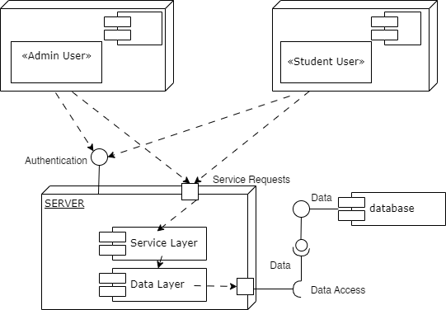

Diagram 3.2.2 Component Diagram

**3.2.3 User Classes and Characteristics**

**Students**

*Frequency of Use:* Regular users accessing the platform frequently to explore opportunities.

*Subset of Product Functions Used:* Engage with all core functionalities such as user registration, opportunity listings, search/filtering, and community engagement.

16

*Technical Expertise*: Varied levels of technical proficiency, from basic to intermediate.

*Security or Privilege Levels:* Standard user privileges with access to general features.

*Educational Level/Experience*: Students pursuing various educational levels, from undergraduate to postgraduate (including high school students also)

*Importance:* Most important user class as they are the primary target audience and drive platform usage.

**Employees and organizations**

*Frequency of Use*: Periodic use to check the posted opportunities (made by admin).

*Subset of Product Functions Used*: Cannot access employer dashboard, post opportunities or review student profiles, because these features can be implemented later after the platform has gone into production/use.

*Educational Level/Experience:* Varied, typically professionals or representatives from organizations.

*Importance:* Important for providing opportunities and engagement on the platform.

**Administrators:**

*Frequency of Use*: Regular use for platform management, monitoring, and maintenance.

*Subset of Product Functions Used:* Access administrative dashboard, manage user accounts, monitor platform activity, and ensure data integrity. (responsible for everything)

*Technical Expertise:* High technical proficiency for system administration tasks.

*Security or Privilege Levels:* Highest privileges with full access to system controls and settings.

*Educational Level/Experience*: Technical professional or platform administrator.

*Importance*: Crucial for maintaining platform functionality and security.

17

**Guest Users**

*Frequency of Use:* Infrequent or one-time use to explore the platform without creating an account.

*Subset of Product Functions Used:* Limited access for a limited time to public information.

*Security or Privilege Levels:* Restricted privileges as they do not have user accounts.

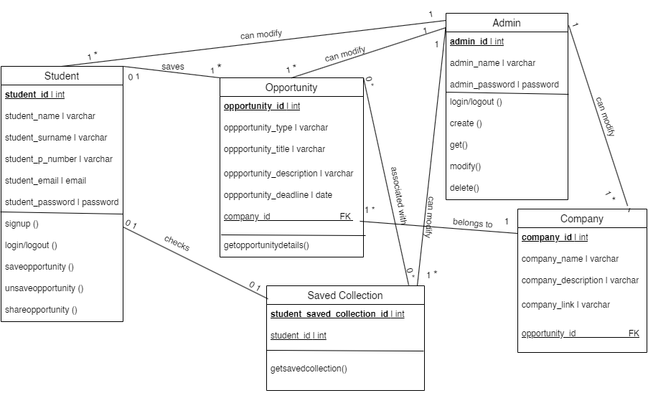*Importance:* Less important compared to registered users but can contribute to platform visibility as they can become future/potential users with accounts.

Diagram 3.2.3 Class Diagram

**3.2.4 Database Diagram**

1. “student” Table consisting of student data :

○ student_id (Primary Key)

○ student_name

○ student_surname

○ student_p_number

○ student_email 18

○ student_password

2. “opportunity” Table consisting of opportunities data :

○ opportunity_id (Primary Key)

○ opportunity_type

○ opportunity_title

○ opportunity_description

○ opportunity_desadline

○ company_id (Foreign Key)

3. “company” Table consisting of company related data :

○ company_id (Primary Key)

○ company_name

○ company_description

○ company_link

○ opportunity_id (Foriegn Key)

4. “saved_collection” Table consisting of saved opportunities by a student:

○ student_saved_collection_id ( Primary Key)

○ opportunity_id (Foriegn Key)

student_id (Primary Key)

● Student Side

Each student once registered in the website is identified by his unique “student_id”. The

“student_email” and “student_password” data are reused every time the student wants

to log-in. The “student_id” for a particular student is created when a student is

registered.

19

● Admin side

The “admin_username” and “admin_password” are used by the administrator in order to

gain access to the Wordpress website and log in. The admin in our application is able to

create, get, modify and delete any particular data from the database that he wants. He

is able to access all of the database tables along with changing the given data for each

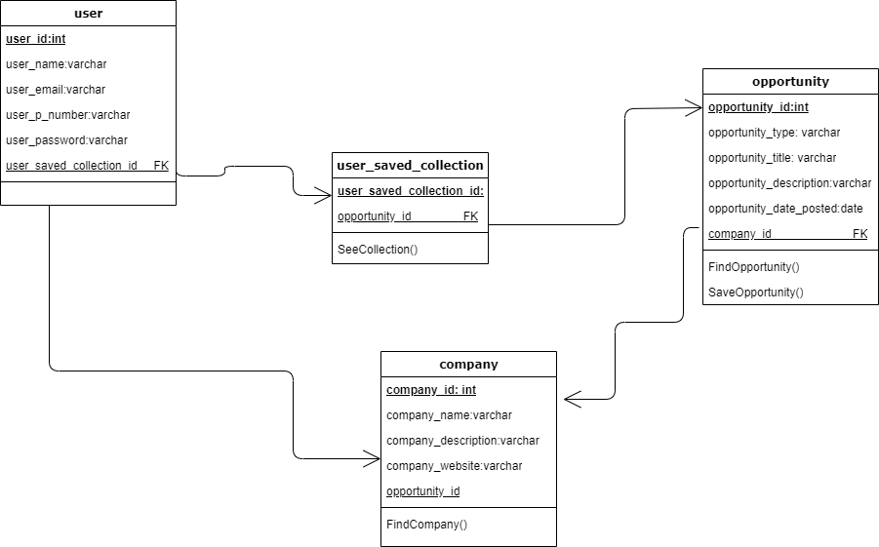one of them.

Diagram 3.2.4 Database Diagram

**3.2.5 Sequence Diagram**

*Open the website Studental:*

* To log in into the website, the student enters the email and password.
* The website verifies authentication by comparing the student credentials in the database if the credentials are valid.
* The student can access the homepage where he/she can find the opportunities categorized by the company, by its type or can just scroll down the opportunities

20

without any filter.

* In case of unsuccessful authentication the website informs the student to recheck their credentials.
* The list of opportunities is retrieved from the database.
* The student is presented with the retrieved opportunities as mentioned above

*Check an opportunity:*

* From the opportunities listed in the website, the student chooses the one he/she is most interested in.
* After clicking on the opportunity, they can see more details about it and also about the company that has posted it.
* They cannot directly apply for a certain position because they have to follow the link/instructions given to make the application at the company offering it.
* A use case diagram shows the different ways people (or other systems) can use your application.
* Activity diagrams show the flow of activities in your application. They're like flowcharts that show the steps involved in completing a task.

21

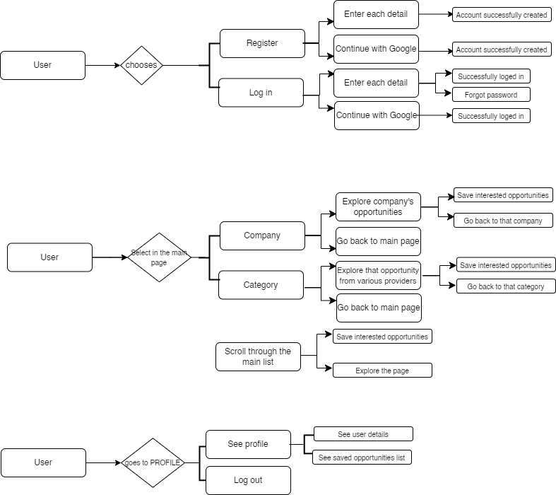

Figure 3.2.5 Sequence Diagram

22

**CHAPTER 4**

**TOOLS AND ENVIROMENT**

**4.1 Hardware Interface**

It does not have specific hardware requirements and users can access it using any device with a web browser and internet connection, including desktop computers, laptops, etc.

***Supported Device Types:***

The Studental platform is designed to be accessible across various device types, including:

Desktop computers (Windows, macOS, Linux)

Laptops (Windows, macOS, Linux)

Tablets (iOS, Android)

Smartphones (iOS, Android)

***Data and Control Interactions:***

Data Interactions:

The software communicates with hardware components to receive user inputs (e.g., keyboard input, touch input) for navigating the platform, filling forms, and interacting with elements.

Control Interactions:

User actions on hardware devices (clicks, taps, swipes) control the navigation flow within the platform, such as moving between pages, opening dialog boxes, and submitting forms.

***Communication Protocols:***

The platform utilizes standard communication protocols for data transmission and interaction with hardware components:

23

HTTP/HTTPS protocols for secure communication between the user's device and the Studental server.

TCP/IP protocols for reliable data transmission over networks.

**4.2 Software Interface**

**Web Browsers**

- Studental is accessed through web browsers, ensuring compatibility with major browsers:

- Google Chrome (latest version)

- Mozilla Firefox (latest version)

- Microsoft Edge (latest version)

- Safari (latest version)

24

**CHAPTER 5**

**TESTING**

5.1 Test Cases

**Login**

Test Case ID: **TC_Login_1**

Test Scenario: Verify Login

Test Case Description: Validate successful login with valid credentials.

Pre-Condition: Valid username and password are required to perform login.

Test Steps:

* Enter a valid username.
* Enter a valid password.
* Click on the Login button.

Test Data:

* Valid username
* Valid password

Expected Result: Successful login, the main screen of the application should be displayed.

Actual Result: Successful login, the main screen of the application is displayed.

Status: Pass

Test Case ID: **TC_Login_2**

Test Scenario: Verify Login

Test Case Description: Validate login with a valid username and an invalid password.

Pre-Condition: Valid username and password are required to perform login.

Test Steps:

* Enter a valid username.
* Enter an invalid password.

25

* Click on the Login button.

Test Data:

* Valid username
* Invalid password

Expected Result: No matched username/password error message should be displayed.

Actual Result: No matched username/password error message is displayed.

Status: Pass

Test Case ID: **TC_Login_3**

Test Scenario: Verify Login

Test Case Description: Validate login with an invalid username and a valid password.

Pre-Condition: Valid username and password are required to perform login.

Test Steps:

* Enter an invalid username.
* Enter a valid password.
* Click on the Login button.

Test Data:

* Invalid username
* Valid password

Expected Result: No matched username/password error message should be displayed.

Actual Result: No matched username/password error message is displayed.

Status: Pass

Test Case ID: **TC_Login_4**

Test Scenario: Verify Login

Test Case Description: Validate login with an invalid username and an invalid password.

26

Pre-Condition: Valid username and password are required to perform login.

Test Steps:

* Enter an invalid username.
* Enter an invalid password.
* Click on the Login button.

Test Data:

* Invalid username
* Invalid password

Expected Result: No matched username/password error message should be displayed.

Actual Result: No matched username/password error message is displayed.

Status: Pass

**User/ Student Registration**

Test Case ID: **TC_SREG_1**

Test Scenario: Verify User Registration Details

Test Case Description: Validate successful user registration with valid name, email, and new

password.

Pre-Condition: Valid data is required to be entered.

Test Steps:

* Enter a valid name.
* Enter a valid email.
* Enter a valid password.
* Click on the Sign-Up button.

Test Data:

* Valid name

27

* Valid email
* Valid password

Expected Result: Successful registration, user added successfully.

Actual Result: Successful registration, user added successfully.

Status: Pass

Test Case ID: **TC_SREG_2**

Test Scenario: Verify Student Registration Details

Test Case Description: Validate student registration details with a name, already registered email, and new password.

Pre-Condition: Data is required to be entered.

Test Steps:

* Enter a name.
* Enter an already registered email.
* Enter a valid password.
* Click on the Sign-Up button.

Test Data:

* Valid name
* Already registered email
* Valid password

Expected Result: Email ID already registered error message should be displayed.

Actual Result: Email ID already registered error message is displayed.

Status: Pass

Test Case ID: **TC_SREG_3**

Test Scenario: Verify Student Registration Details

28

Test Case Description: Validate staff registration details when required fields are left blank.

Pre-Condition: No specific pre-conditions.

Test Steps:

* Click on the Sign-Up button without entering anything in the required fields.

Test Data: No data is entered.

Expected Result: Required fields are blank error message should be displayed.

Actual Result: Required fields are blank error message is displayed.

Status: Pass

**Save opportunity**

Test Case ID: **TC_Opportunity_1**

Test Scenario: Save an opportunity

Test Case Description: Validate successful addition of an opportunity at user’s personal account.

Pre-Condition: Save option clicked at opportunity page.

Test Steps:

* Click on the Save button/icon .

Test Data:

Expected Result: Successful addition of the opportunity.

Actual Result: Successful addition of the opportunity, course added successfully.

Status: Pass

29

**CHAPTER 7**

**CONCLUSION AND FUTURE WORK**

In conclusion, the website “Studental" project represents a significant step forward in addressing the challenges that students face in accessing relevant opportunities and bridging the gap between academic knowledge and practical skills. By consolidating internship, scholarship, employment, and training opportunities into a centralized platform, this project aims to streamline the search process and empower students in Albania to explore, pursue, and succeed in their chosen career paths.

The platform's key features, such as user registration and profiles, opportunity listings, search functionality, user dashboard, and community engagement tools, are designed to enhance usability, accessibility, and user experience. These features align with the project's objectives of facilitating access, bridging the knowledge gap, empowering decision-making and expanding global reach.

While the initial release of the website “Studental" platform will focus on essential features to establish functionality and usability, there are several areas for future work and enhancements:

1. **Enhanced User Feedback:** Continuously gather user feedback to improve and enhance the platform's functionality, usability, and relevance to students' needs. Implement feedback mechanisms such as surveys, ratings, and user reviews.

2. **Integration of Artificial Intelligence:** Explore the integration of AI technologies to personalize user experiences, provide recommendations based on user preferences, and automate certain processes such as opportunity matching and notifications.

30

3. **Partnerships and Collaborations:** Forge partnerships with educational institutions, employers, and organizations to expand the platform's reach and offerings. Collaborate with industry stakeholders to tailor opportunities and resources to meet industry demands.

4. **Continuous Platform Optimization:** Regularly update and optimize the platform to ensure scalability, sustainability, and adherence to evolving technological standards and user requirements. Conduct regular usability testing and performance evaluations.

5. **Accessibility Improvements**: Prioritize accessibility features and compliance with accessibility standards to ensure inclusivity and usability for all users, including those with disabilities.

By addressing these areas for future work, the website “Studental" platform can continue to evolve as a valuable resource for students in Albania, empowering them to navigate their academic and career journeys effectively and achieve their aspirations.

31

**REFERENCES**

[1] M. L. Savickas, "Career Counseling in the Postmodern Era," Journal of Career Development, vol. 36, no. 1, pp. 58-63, Jun. 2011. [Online]. Available: https://doi.org/10.1177/0894845310389082

[2] Y. S. Chang and S. K. Chu, "Developing a Career E-Portfolio for College Students: The Case of the University of Hong Kong," in Proceedings of the 2011 IEEE International Conference on Information and Education Technology, Chongqing, China, 2011, pp. 225-229. [Online]. Available: https://doi.org/10.1109/ICIET.2011.6026570

[3] M. Akcaoglu and E. Lee, "Using Self-Assessment to Enhance Online Learning: Lessons from Web-Based Educational Environments," in Proceedings of the 2016 IEEE International Conference on Educational Innovation through Technology, Tainan, Taiwan, 2016, pp. 85-89. [Online]. Available: https://doi.org/10.1109/EITT.2016.47

[4] A. Gajewska and M. Mrozek, "Enhancing Accessibility in Web-Based Career Services for Students with Disabilities," in Proceedings of the 2020 IEEE Global Humanitarian Technology Conference, Seattle, WA, USA, 2020, pp. 67-72. [Online]. Available: https://doi.org/10.1109/GHTC46280.2020.9402416

[5] D. A. Norman, The Design of Everyday Things, Revised and Expanded Edition. New York: Basic Books, 2013.

32

[6] T. Tullis and W. Albert, Measuring the User Experience: Collecting, Analyzing, and Presenting Usability Metrics, 2nd ed. Amsterdam: Elsevier, 2013.

[7] M. S. Granovetter, "The Strength of Weak Ties," American Journal of Sociology, vol. 78, no. 6, pp. 1360-1380, May 1973. [Online]. Available: https://doi.org/10.1086/225469

[8] G. Cognet and K. Laachir, "The Impact of International Experience on Students’ Career Development and Intercultural Competence," in Proceedings of the 2016 IEEE International Conference on Teaching, Assessment, and Learning for Engineering, Bangkok, Thailand, 2016, pp. 234-239. [Online]. Available: https://doi.org/10.1109/TALE.2016.7851781

33

**APPENDICES**

Appendix A Website Screenshots 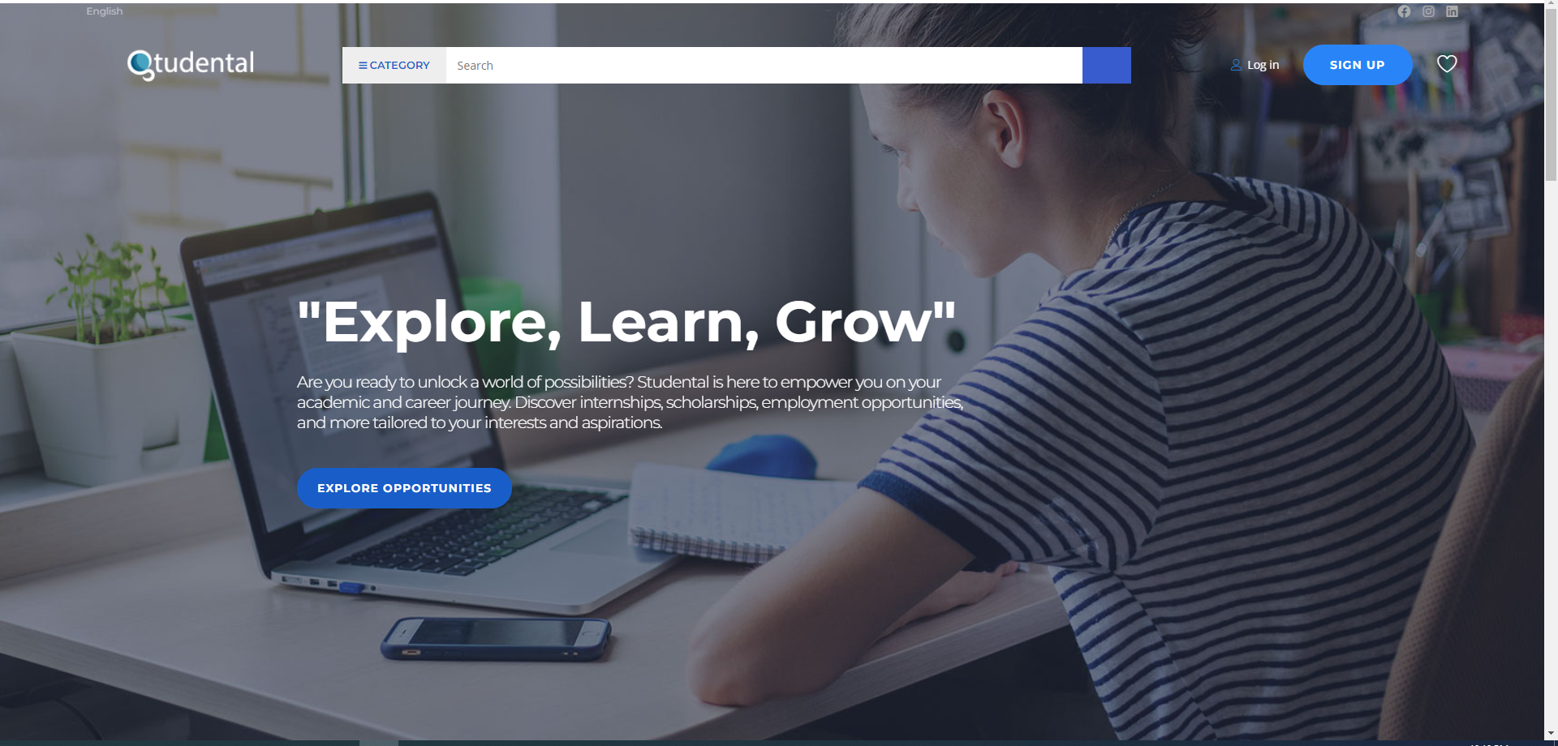Figure 1.1 Website Homepage, first part

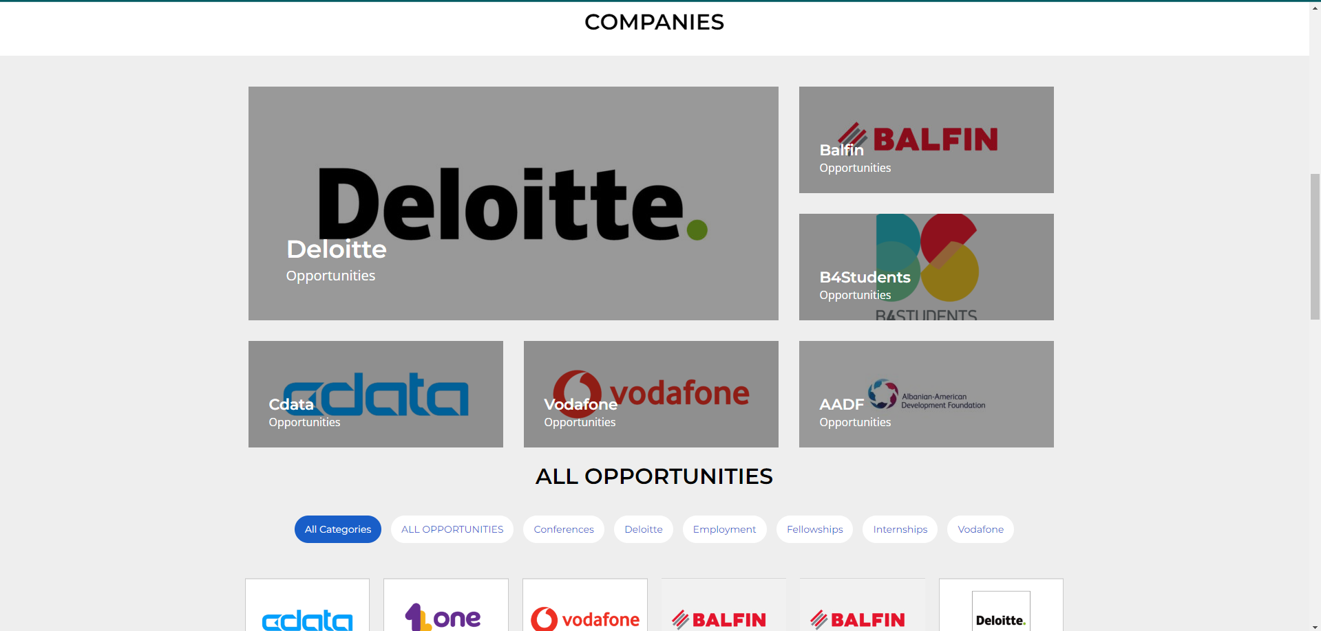

Figure 1.2 Website Homepage, second part

34

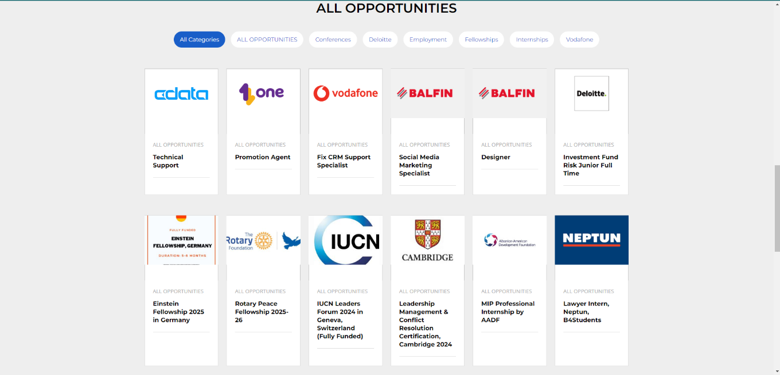

Figure 1.3 Website Homepage, third part

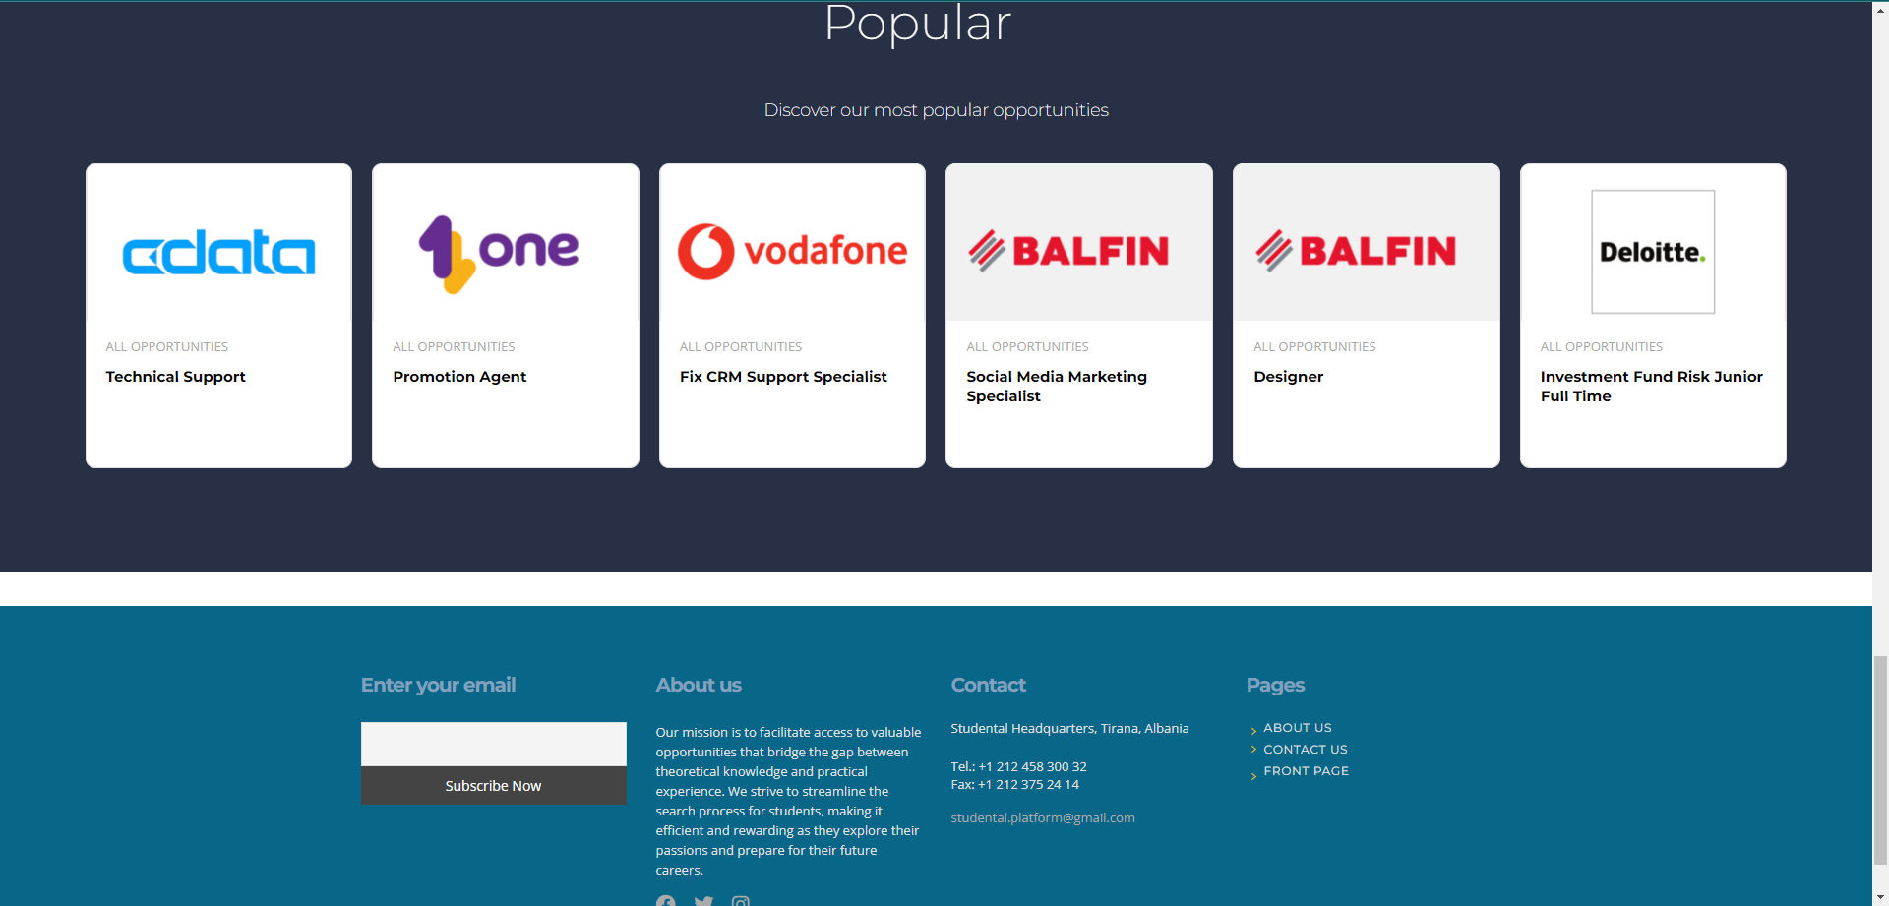

Figure 1.4 Website Homepage, fourth part

35

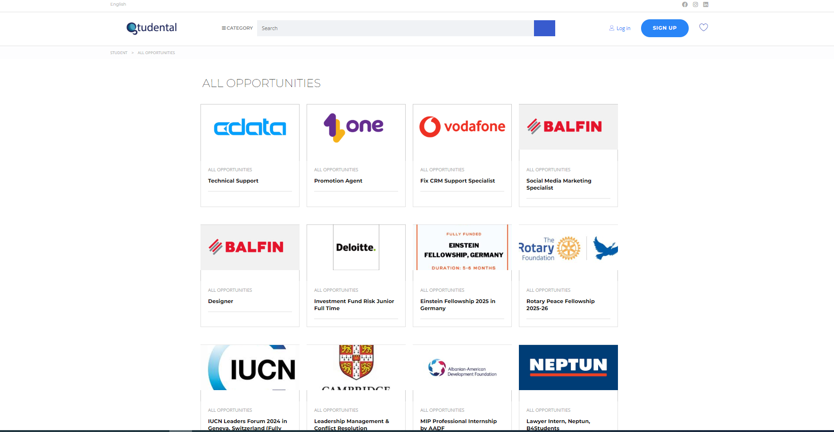

Figure 2.1 All Opportunities Page, after clicking ‘Explore Opportunities’ button, first part

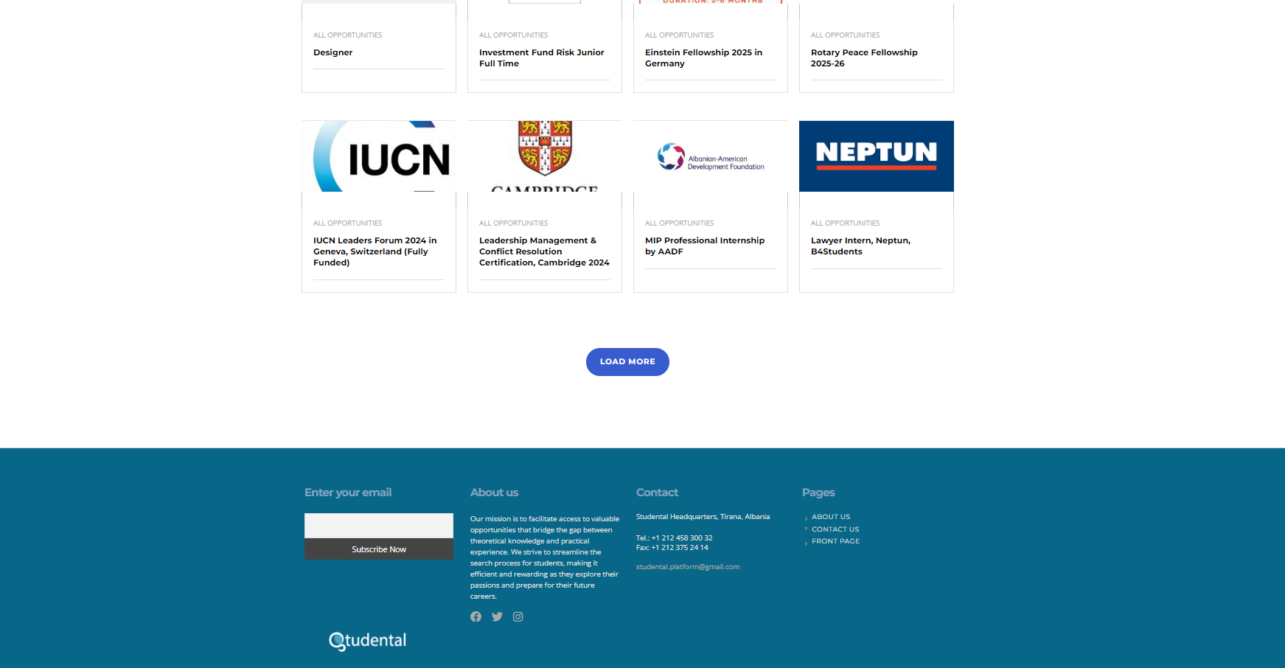

Figure 2.2 All Opportunities Page, after clicking ‘Explore Opportunities’ button, second part

36

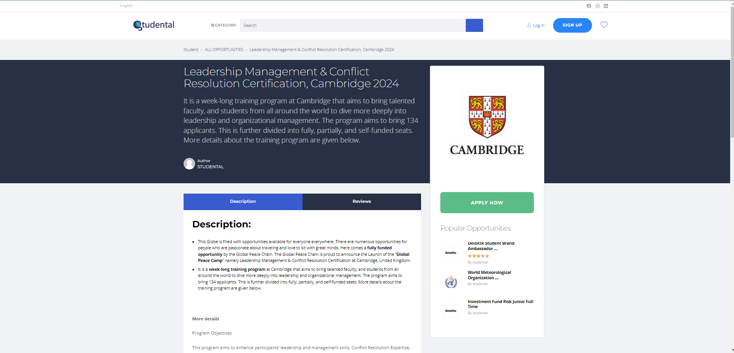

Figure 3.1 One opportunity opened after clicking ‘Read more’ button first part

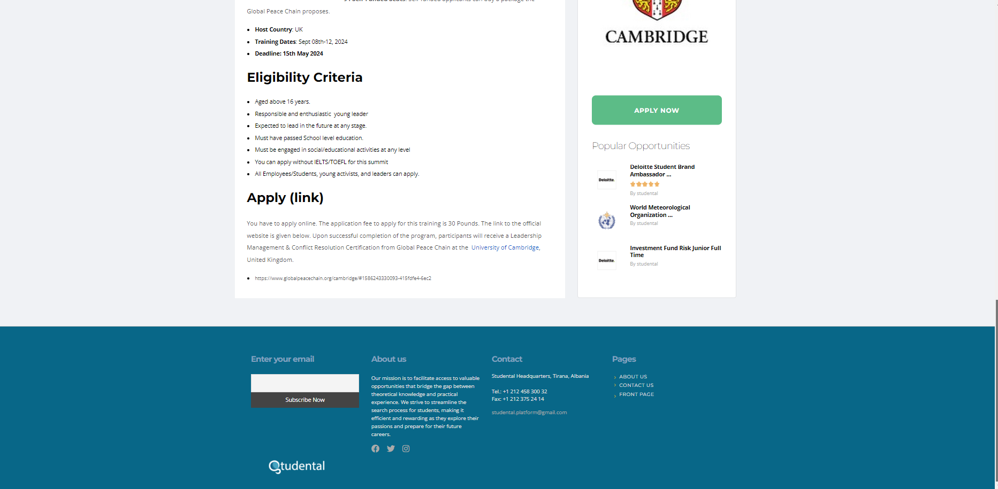

Figure 3.2 One opportunity opened after clicking ‘Read more’ button second part

37

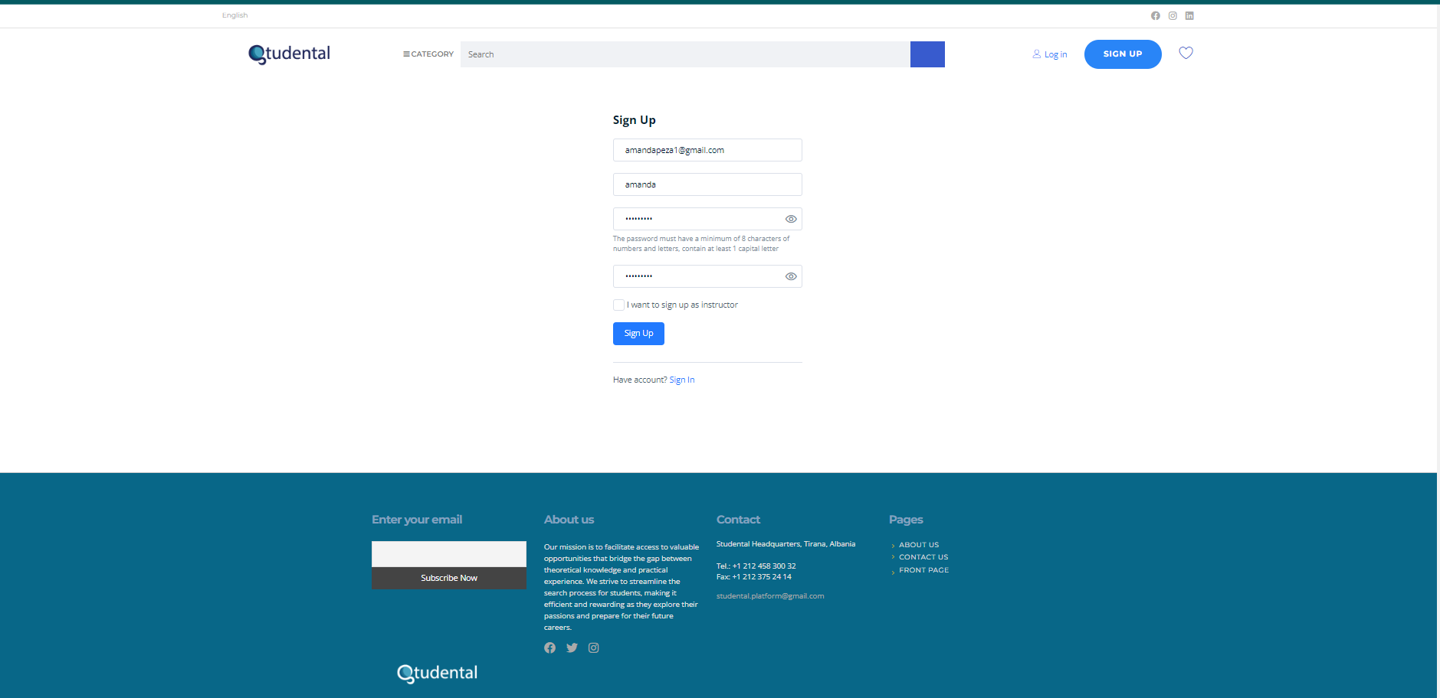

Figure 4.1 Login example

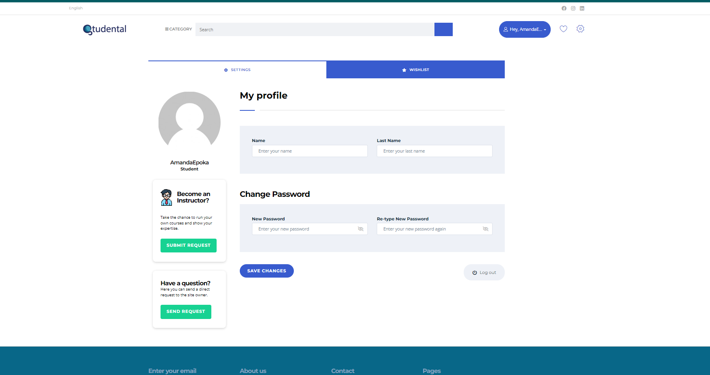

Figure 5.1 User Dashboard

38

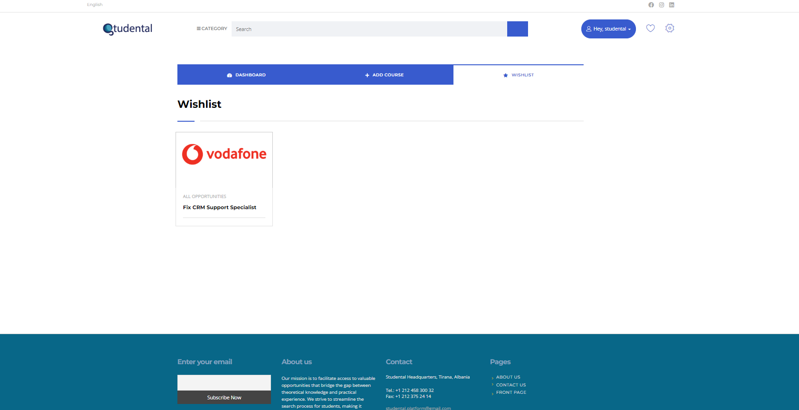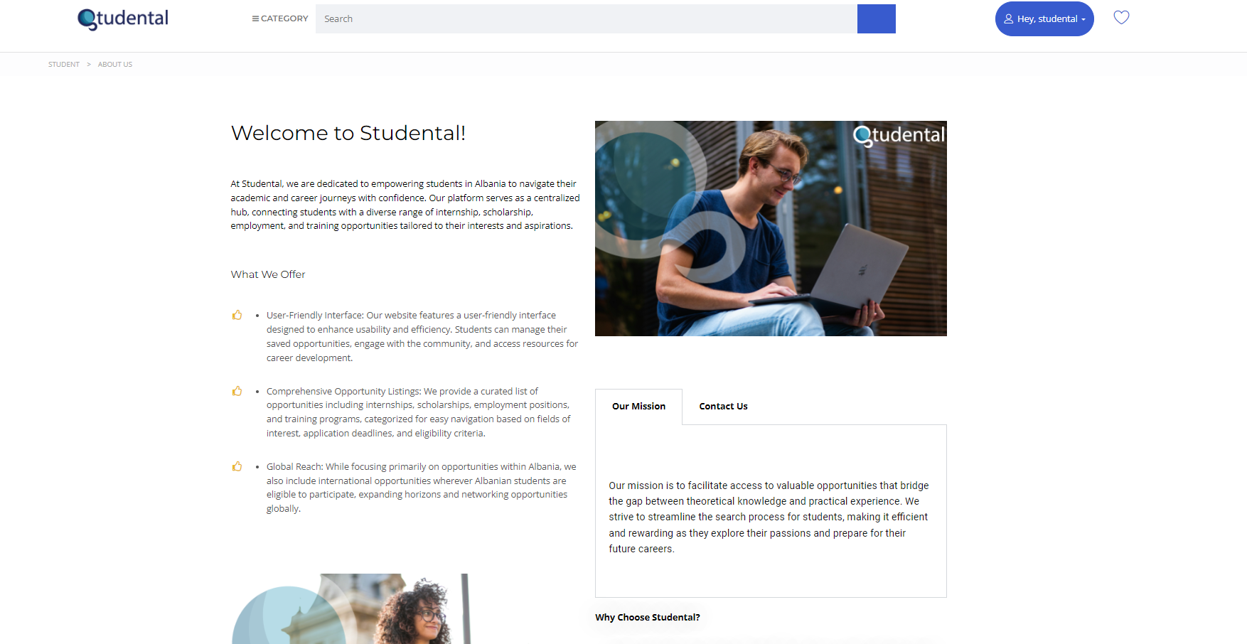Figure 5.2 User Wishlist

Figure 6.1 ‘About Us’ page, first part

39

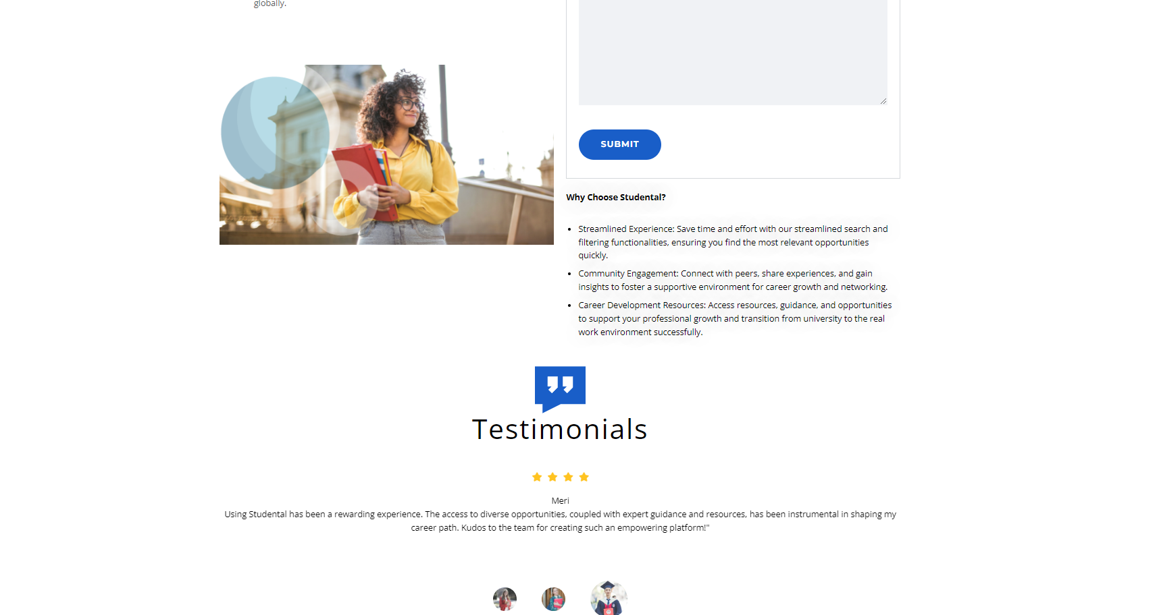

Figure 6.2 ‘About Us’ page, second part

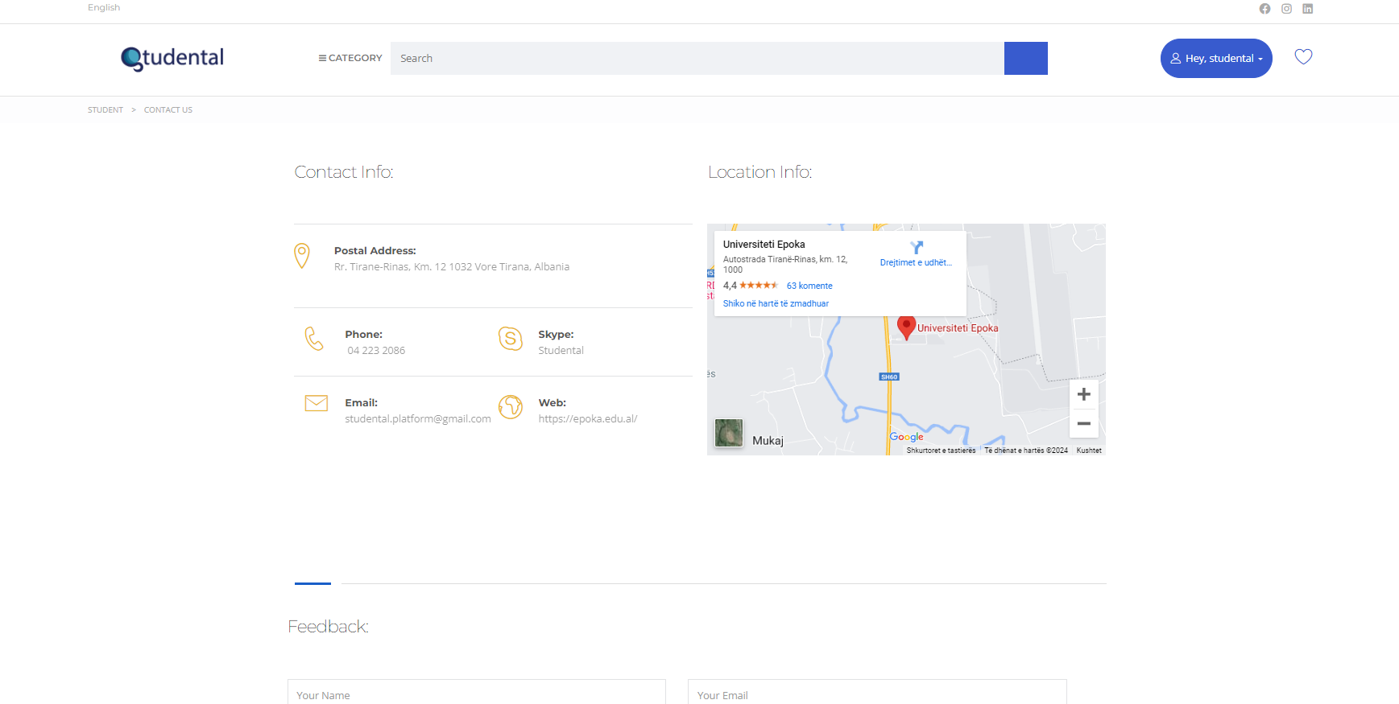

Figure 7.1 ‘Contact Us’ page, first part

40

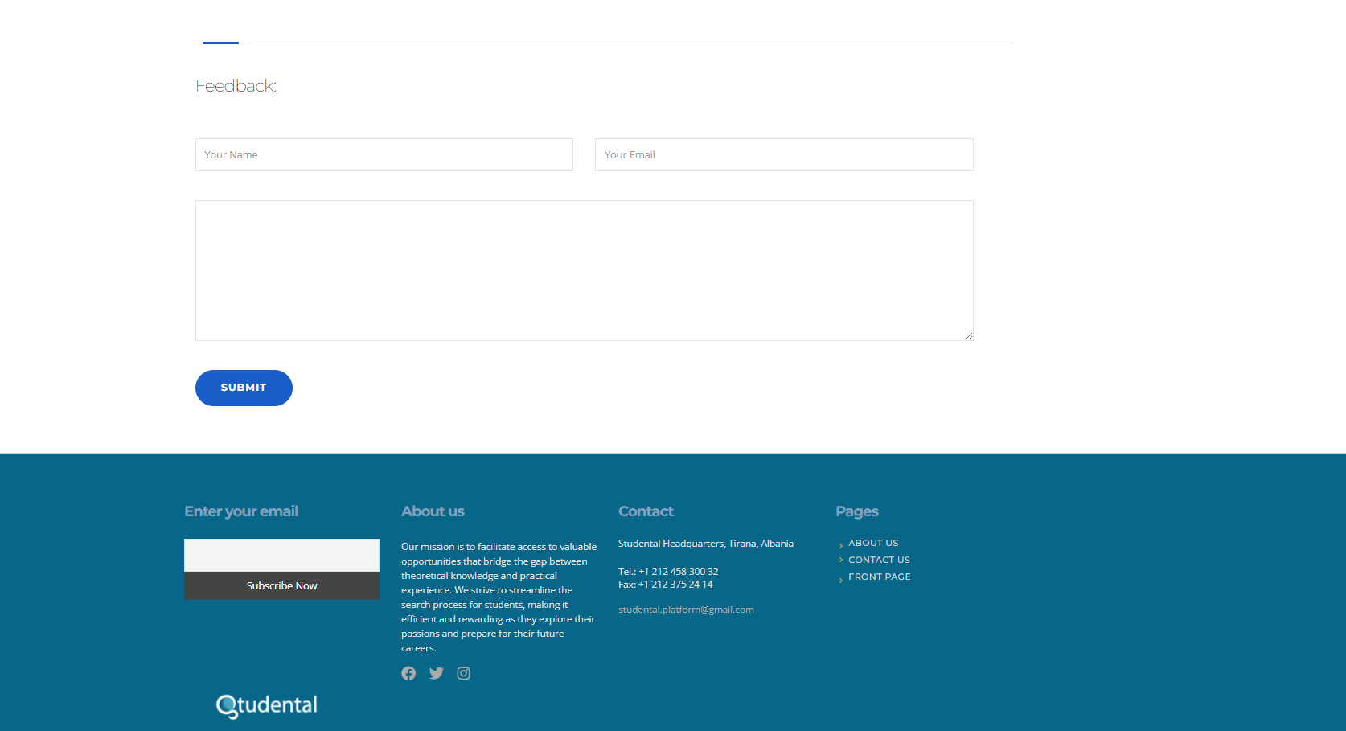

Figure 7.2 ‘Contact Us’ page, second part

Link to access the website: <https://www.student-al.com/>

41

**CURRICULUM VITAE**

Amanda Peza was born on 29 November 2002, in Tirana. She received her BSc degree in Business Informatics in 2024 from Epoka University, Tirana, Albania, and completed her high school education at Sami Frashëri High School in 2021. She has worked as a Student Brand Ambassador at Deloitte since October 2023, promoting recruitment opportunities and utilizing social media strategies. During the summer of 2023, she participated in the Work & Travel USA Program, working in several american businesses. In 2022, she worked as a Graphic Designer at Security Solution & Distribution, designing product catalogs and creating social media posts. She has been actively involved in extra-curricular activities, serving as the Lead of the Google Developer Student Club and an Ambassador for Women Techmakers at Epoka University. She has also held the role of Operations & Marketing Director for the Google Developer Student Club, managing social media. Her volunteering experience includes roles with UEFA, the Solidarity Action Day Movement in Europe (SAME), the Tirana Marathon, and the Red Cross Albania. She has completed internships at the Career Planning and ALUMNI Office at Epoka University and a Vodafone International Virtual Internship, focusing on digital technologies.

42